System Requirements Specification

for

Whatsapp Mobile Version

Prepared by:

MRV SAI KRISHNA (411738)

MRV MANIDEEP (411741)

M SANDEEP (411743)

A SAI PRASHANTH (411703)

WhatsApp Analysis & Design

CONTRIBUTIONS:

MRV SAI KRISHNA - Front End, Back End

MRV MANIDEEP - Front End, Back End

M SANDEEP - UML diagram, ER diagram

A SAI PRASHANTH - Documentation

Table of Contents

Table of Contents ii

Revision History ii

1. Introduction 1

1.1 Purpose 1

1.2 Document Conventions 1

1.3 Intended Audience and Reading Suggestions 1

1.4 Project Scope 1

1.5 References 1

2. Overall Description 1

2.1 Product Perspective 1

2.2 Product Features 2

2.3 Design and Implementation constraints 2

2.4 User classes and characteristics 2

2.5 Operating environment 2

2.6 Assumptions and Dependencies 2

3. System Features 3

3.1 System Feature 1 3

3.2 System Feature 2 (and so on) 3

4. External Interface Requirements 3

4.1 User Interfaces 4

4.2 Hardware Interfaces 4

4.3 Software Interfaces 4

5. Other Nonfunctional Requirements 5

5.1 Performance Requirements 5

5.2 Software Quality Attributes 5

6. Other Requirements 5

Appendix A: Analysis Models 6

Appendix B: Issues List 7

Revision History

|  |  |  |  |
| --- | --- | --- | --- |
| **Name** | **Date** | **Reason For Changes** | **Version** |
|  |  |  |  |
|  |  |  |  |

# Introduction

## Purpose

This document describes in substantial detail, the software requirements of WhatsApp, an offline instant messaging application. This document will describe the problems WhatsApp intends to address, the functional requirements and non-functional requirements of the proposed system.

## Document Conventions

No conventions.

## Intended Audience and Reading Suggestions

This document is intended for the stakeholders of the application, to assist in the development process of WhatsApp as well as to serve a reference to clarify any future issues that the stakeholders may run into.

## Project Scope

WhatsApp is a proprietary, cross-platform, encrypted instant messaging client for smartphones. It doesn't ses the Internet to send text messages to other users using standard cellular mobile numbers.

## References

<http://www.google.com>

<https://play.google.com/store/apps/details?id=com.whatsapp>

<https://www.tutorialspoint.com>

# Overall Description

## Product Perspective

WhatsApp does not work independently. It works together with the internal servers and sending and receiving application on either end devices.

**Communication interface:** WhatsApp communicates with the internal servers via a database as a communication network.

**Software interface:** The messages sent via the communication network are specific to the target recipient. At any point, two known users will participate in the application.

**Hardware interface:** The software will run on any device running on iOS, Android, Symbian, BlackBerry operating systems.

**User interfaces:** The GUI of the Application is user friendly and need no external assistance to understand the application.

**Customer:** The customer user interface should be intuitive, such that 99.9% of all new WhatsApp users are able to use the Application without any assistance.

**Message Processing:** Every message send through the application is processed by the internal servers and sent to the recipient. Message processing is done at very high processing rates so as to avoid delay in the conversations between the users.

## Product Features

WhatsApp should work 24 hrs. The Application on a smartphone is linked to a single user account. It collects information about a simple account transaction, communicates with the internal severs for message processing and delivers the message to the recipient in time to receive their reply. WhatsApp provide their own software for their own servers. The internal server software requires appropriate record keeping and security provisions. The software must handle concurrent accesses to the same user correctly.

## Design and Implementation Constraints

Login

**Validate User:**

Validate for User’s Mobile Number by Password.

Check for any previous existing User Backups on the device.

If a Backup is available, then Restore Backup.

## User Classes and Characteristics

**Characteristics:** There are several users of the WhatsApp network:

Customers are simple members of the general public with no special training.

## Operating Environment

The hardware, software and technology used should have following specifications:

Ability to use Network resources

Keypad

Continuous power supply

Able to take input from user

## Assumptions and Dependencies

Hardware never fails

Unlimited number of messages per day

Unlimited number of changes to profile per day

# System Features

**3.1 Functional Requirements**

The functional requirements are organized in two sections First requirements of the application on any device and second requirements of the network resource to connect to the internal servers of WhatsApp.

**3.1.1 Requirements of WhatsApp**

The requirements for the working of WhatsApp Application are organized in the following way

General requirements, requirements for authorization, and requirements for a transaction.

**General Requirements**

**Functional requirement 1:**

**Description:** Send a messagefunction sends a text message to another user of whatsapp.

**Inputs:** Inputs are characters, including numbers and the receiver contact from contact list in DB.

**Processing**; Reads the message from the buffer, stores it in the sender`s device DB, pass it to the Central DB and passes the message to receiver and stores it in the receiver`s device DB.

The message itself – stored in Central DB, Stored in the sender`s and the receiver`s devises DB for history.

**Functional requirement 2:**

**Description:** User RegistrationUser is able to register for the application through a phone number. On installing the application, user must be prompted to register their phone number. If user skips this step, application will close. The user’s phone number will be the unique identifier of his/her account on WhatsApp.

**Functional requirement 3:**

**Description:** On adding New Contacts the application is able detect all contacts from the user’s phone book in DB. If any of the contacts have user accounts with WhatsApp, those contacts must automatically be added to the user’s contact list on WhatsApp.

**Functional requirement 4:**

**Description:** Using User’s contact list from the DataBase.

**Processing:** Checks which contacts in DB have the WhatsApp app, by using accounts DB, and then stores this information in the contacts DB. All contacts that have WhatsApp, appear in WhatsApp contact list on user`s device. If new contact added to contacts list of the DB, the new contact is added to whatsapp contact list.

**Outputs:** WhatsApp messenger contact list.

**3.1.2 Requirements of the Application**

**Authorization**

The internal servers gets a request from a User account to process and send a message to a recipient.

**Functional requirement :**

**Description:** Internal servers checking if the user is authentic.

**Input:** Request from the application about it authenticity

**Processing:** Check if the application is a valid application or not

**Output:** Valid or invalid application.

# External Interface Requirements

## User Interfaces

The customer user interface should be intuitive, such that 99.9% of all new Applications are able to complete their transactions without any assistance.

## Hardware Interfaces

The hardware should have following specifications:

Keypad

Continuous power supply

Ability to connect to WhatsApp network

Ability to take input from user

Ability to validate user

## Software Interfaces

The software interfaces are specific to a proprietary, cross-platform, encrypted instant messaging client.

# Other Nonfunctional Requirements

## Performance Requirements

It must be able to perform in adverse conditions extremely low battery on device.

Uninterrupted connections

High data transfer rate.

## Software Quality Attributes

**5.2.1 Availability:** The WhatsApp internal Server has to be available 24 hours a day.

**5.2.2 Security:** The Application should provide maximal security in order to make that much more transparent there are the following requirements:

It must be impossible to plug into the internal server network.

**5.3.3 Maintainability:** Only maintainers are allowed to connect into internal servers.

# Other Requirements

**6.1 Data Base**

The Application must be able to use several data formats according to the data formats that are provided by the data bases. A transaction should have all the properties of a data base transaction (Atomicity, Consistency, Isolation, and Durability).

Appendix A: Analysis Models

E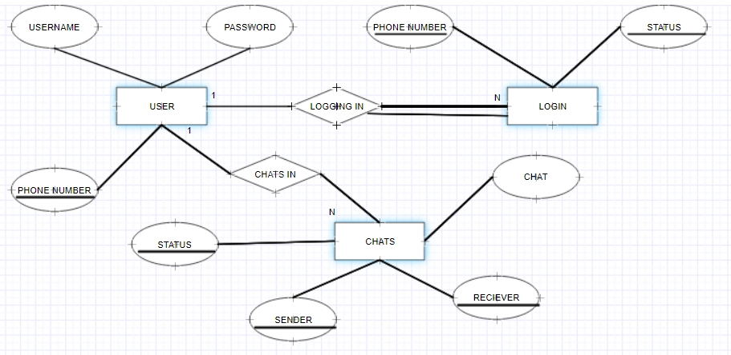R DIAGRAM

UML DIAGRAM

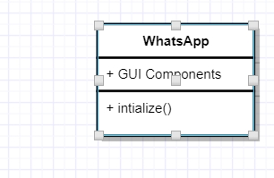

# Relation Schema

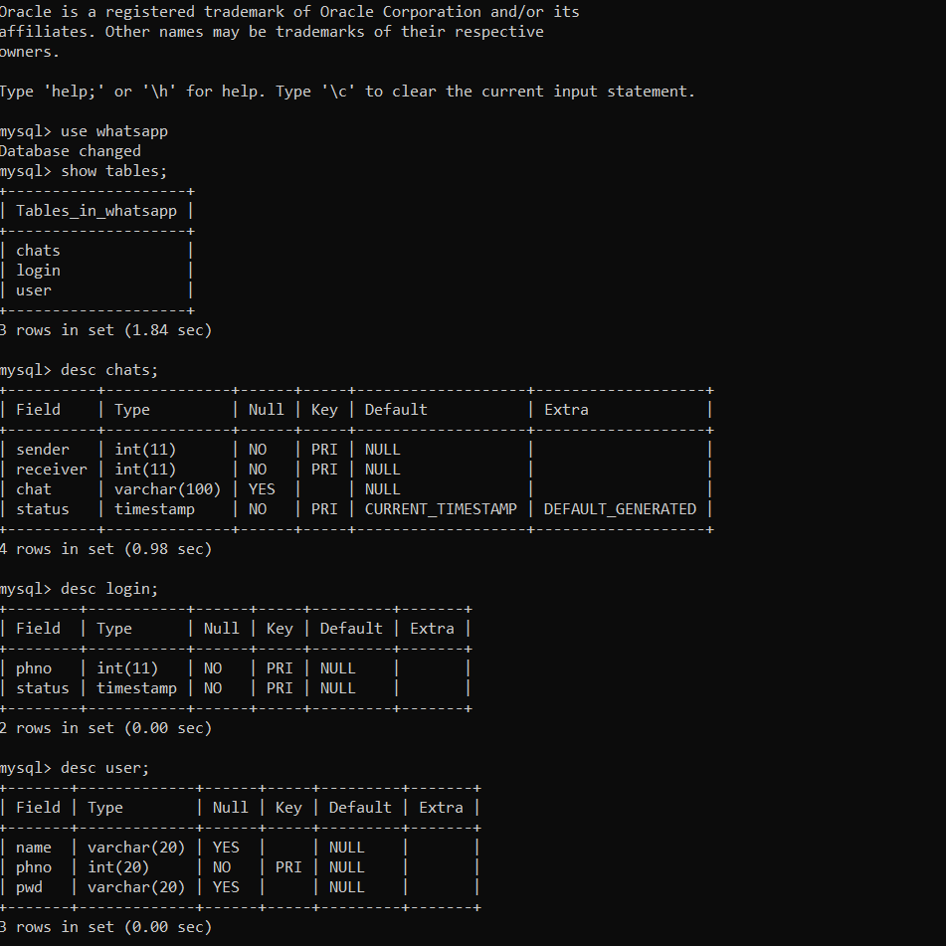

Appendix B: Issues List

Calls cannot be implemented as it is offline version of whatsapp.

Status may not be implemented as it is difficult to store and retrieve the images from MYSQL database.